BRCA1 Pathway
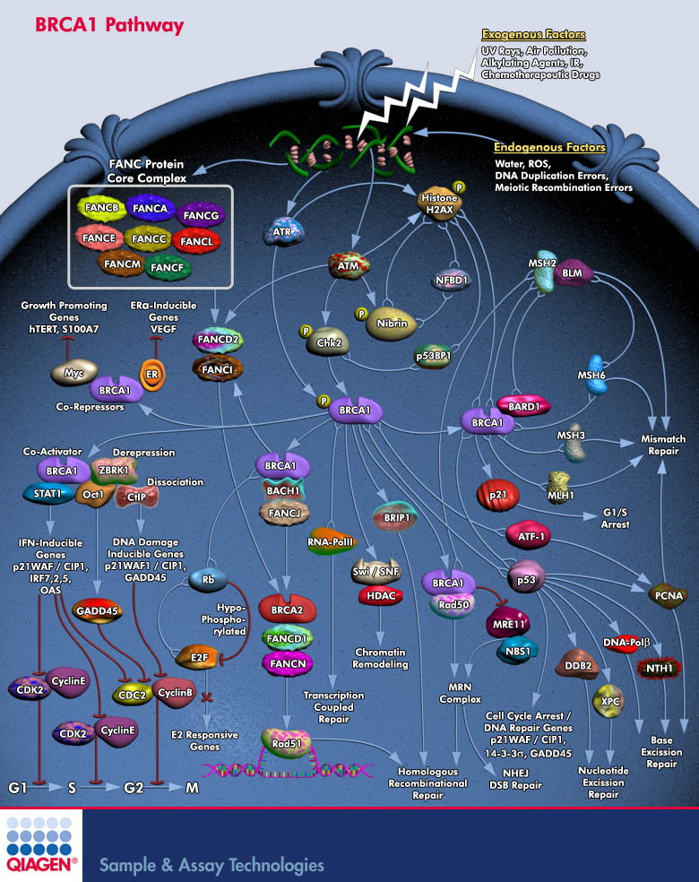

Explore and order pathway-specific siRNAs, real-time PCR assays, and expression vectors. View pathway information and literature references for your pathway.
BRCA1 Pathway
The maintenance of genome integrity is essential to all life, but is particularly important to long-lived multicellular organisms, which are susceptible to cancer. DNA damage can take the form of base modifications, strand breaks, interstrand cross-links and other lesions. These requirements imply that signaling networks not only sense the presence of DNA damage, but also receive specific input such as the chemical nature of the damage, the timing of the cell cycle, the type of cell and the location of damage on the DNA. BASC (BRCA1-Associated Genome Surveillance Complex), a super complex of BRCA1 (Breast Cancer Susceptibility Protein-1), is key to recognizing and repairing DNA damage. This complex includes tumor suppressors and DNA damage repair proteins MSH2, MSH6, MLH1, ATM (Ataxia-Telangiectasia), BLM (Bloom syndrome), and the Rad50-MRE11 (Meiotic Recombination-11)-NBS1 (Nijmegen Breakage Syndrome) protein complex. In addition, RFC (DNA Replication Factor-C), a protein complex that facilitates the loading of PCNA onto DNA, is also part of BASC (Ref.1 and 2). Eleven or more genetically distinct groups of FA have been described (FANCA , FANCB, FANCC, FANCD1, FANCD2, FANCG, FANCE, FANCF and FANCL), each caused by recessive mutations in a different gene. DNA damage activates the monoubiquitylation of FANCD2 (Fanconi Anemia subtype D2 protein), which is targeted to subnuclear foci, where it co-localizes with BRCA1 and Rad51 (Ref.3 4, 5 and 6). Five of the proteins (FANCA, FANCC, FANCE, FANCF and FANCG) assemble in a multisubunit nuclear complex required for the activation of FANCD2 to a monoubiquitinated isoform (FANCD2-Ub), either in response to DNA damage or during S-Phase of the Cell Cycle, thereby targeting FANCD2 to DNA repair nuclear foci containing BRCA1, BRCA2 andRad51, which are important in maintaining genomic stability by promoting homologous recombination repair (Ref.7).BRCA1 is a nuclear phosphoprotein, which interacts with Rad51, a human homolog of RecA, and with the Rad50-MRE11-NBS1 complex. In living cells, BRCA1 exists mostly as a heterodimeric complex with BARD1 (BRCA1-Associated RING Domain-1). BRCA1-BARD1 co-localizes with DNA replication and repair factors in response to DNA damage. BRCA1-BARD1 heterodimers exhibit significant E3 Ub Ligase activity and the BARD1 RING finger domain greatly potentiates the Ligase activity of the BRCA1 RING finger (Ref.8). The ATM and ATR (ATM and Rad3 related) kinases, both implicated in responses to genotoxic stress, are also involved for the radiation-induced phosphorylation ofBRCA1 (Ref.9). Normally, ATM phosphorylates Chk2 (Chk1 Checkpoint Homolog), which in turn phosphorylatesBRCA1. The ring finger of BRCA1 confers ubiquitin ligase activity that is markedly enhanced when complexed with another ring-containing protein, BARD1 (BRCA1 Associated Ring Domain-1), and is required for the function of this tumor suppressor protein in protecting genomic integrity (Ref.10). ATR and ATM kinase targets also include repair enzymes likeRad51, Chk1 and Chk2. In response to ionizing radiation, ATM phosphorylates NBS1 leading to phosphorylation ofFANCD2 and the establishment of an S-Phase checkpoint response, and in response to Mitomycin-C or Hydroxyurea, NBS1 assembles in nuclear foci with MRE11-Rad50 and FANCD2. Like ATM, the MRE11 complex is a crucial upstream regulator of checkpoint responses and DNA-repair responses in all eukaryotic cells. The MRE11 complex assembles withBRCA1 in nuclear foci following DNA damage and regulate homologous recombination repair (Ref.11). BRCA1 inducesGADD45, a p53-regulated and stress-inducible gene that plays an important role in cellular response to DNA damage.BRCA1 activation of the GADD45 promoter is mediated through the OCT1 and CAAT motifs located at the GADD45promoter region (Ref.12). BRCA1 can trigger a G1 arrest that is mediated by transcriptional activation of p21Waf1/Cip1. In addition to its association with holoenzyme, BRCA1 can bind to several different transcription factors, including p53,Myc, STAT1, and CtIP (CBP-Interacting Protein) (Ref.13). BRCA1 acts in concert with STAT1 to differentially activate transcription of a subset of IFN-Gamma target genes and mediates growth inhibition by this cytokine. BRCA1 also binds preferentially to the hypophosphorylated form of Rb (Retinoblastoma Protein) .DNA repair by homologous recombination is mediated by the BRCA1-associated surveillance complex (comprised of BLM, MSH2MSH6 andMRE11Rad50NBS1). BRCA1 can form complexes with both BACH1 and SWI/SNF to mediate chromatin remodeling and homologous recombination. HDACs regulate the access of the SWI/SNFBRCA1 complex to DNA. Finally, BRCA1interacts with Chk1 and PLK1 (Polo-Like Kinase-1) to regulate the G2/M and G1/S checkpoints, possibly via GADD45; thereby linking BRCA1 to the regulation of apoptosis (Ref.14). BRCA1 is a tumor suppressor gene implicated in the predisposition to early onset breast and ovarian cancer. Several functions have also been ascribed to BRCA1 including double strand DNA break repair, participating in genome surveillance, transcription-coupled DNA repair, transcriptional regulation, chromatin remodeling, and ubiquitin ligation and cell cycle checkpoint arrests. In cells, loss of BRCA1 function leads to spontaneous chromosome breakage and sensitivity to DNA damage (Ref.15).

References
- FANCM of the Fanconi anemia core complex is required for both monoubiquitination and DNA repair.
- Mechanisms of increased risk of tumorigenesis in Atm and Brca1 double heterozygosity.
- Fanconi anemia and the cell cycle: new perspectives on aneuploidy.
- Fanconi anemia and biallelic BRCA2 mutation diagnosed in a young child with an embryonal CNS tumor.
- A prototypical Fanconi anemia pathway in lower eukaryotes?
- The structure of the catalytic subunit FANCL of the Fanconi anemia core complex.
- Advances in understanding the complex mechanisms of DNA interstrand cross-link repair.
- BRCA1/BARD1 E3 ubiquitin ligase can modify histones H2A and H2B in the nucleosome particle.
- Tyrosine phosphorylation enhances RAD52-mediated annealing by modulating its DNA binding.
- BRCA1-associated protein 1 interferes with BRCA1/BARD1 RING heterodimer activity.
- MRE11-RAD50-NBS1 is a critical regulator of FANCD2 stability and function during DNA double-strand break repair.
- ATF-2 controls transcription of Maspin and GADD45 alpha genes independently from p53 to suppress mammary tumors.
- Regulated recruitment of tumor suppressor BRCA1 to the p21 gene by coactivator methylation.
- Structure-Function Of The Tumor Suppressor BRCA1.
- BRCA1 and Its Network of Interacting Partners.

